**Continuous Integration and Continuous Deployment**

**Table of Contents**

1. List of AWS services NAPI Consumes 2

2. Deployment using AWS CloudFormation 2

3. Build and Deploy flow 3

4. AWS Services used for Continuous Integration and Continuous Deployment 4

5. Continuous Integration & Continuous Deployment Flow 4

## List of AWS services NAPI Consumes

Following is a list of AWS Services that are either part of existing or can be a part in the future.Some of the services are bundled together i.e. the use of one service is dependent on another. For easier reference the bundled services are highlighted with the same color .

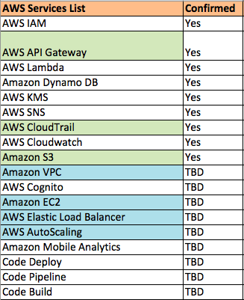

## Deployment using AWS CloudFormation

AWS CloudFormation is being used for deploying the infrastructure required for NAPI on AWS cloud platform using Inline feature of AWS CloudFormation template. All the services can be added as inline except for AWS Lambda. AWS Lambda uses referencing feature of AWS CloudFormation template for the functions.

## Build and Deploy flow

## Macintosh HD:Users:itishatiwari:Desktop:Screen Shot 2017-07-31 at 5.16.28 PM.png

## AWS Services used for Continuous Integration and Continuous Deployment

* 1. AWS CodePipeline – Automates the process of build and deployment of AWS CloudFormation template to the testing environment or production environment. Every time the code is committed in stash the AWS CodePipeline polls the latest code and updates the infrastructure or related CloudFormation template.
  2. AWS CloudFormation- Automates creation of AWS resources and makes it easier to replicate environments in different stages of project
  3. AWS CodeBuild-Compiles and runs the script to deploy CloudFormation template whenever a change in code is committed in stash. Also can be used to run unit tests.

## Continuous Integration & Continuous Deployment Flow

AWS CloudFormation template will create a CodePipeline containing multiple stages starting from connecting the Stash repo and branch as source stage, followed by build using CodeBuild, launch test stack, test using CodeBuild. To proceed with deployment of resources via CloudFormation template or CloudFormation Changeset in specified environment it wait for manual approval. Once approved it proceeds to creates all the resources in the specified environment.